**Name: Maaz Habib**

**Lab Course Title:** Digital Logic Design

**Semester: 3rd Semester**

**Registration No.** 20pwcse1952

Section: C

**DLD Lab**

**Department of Computer System Engineering**



**Submitted to:**

**Engr. Faiz Ullah**

**University of Engineering & Technology, Peshawar**

**Department of Computer System Engineering**

**DLD Lab # 9**

**Aim:**

Verification of state tables of R-S and D flip-flops (with PRESET and CLEAR inputs) using NAND gates.

**Apparatus:**

IC 7410 (3-input NAND Gate).

**Theory:**

In case of sequential circuits, the effect of all previous inputs on the outputs is represented by a state of the circuit. Thus, the output of the circuit at any time depends upon its current state and the input. The relationship that exists among the inputs, outputs, present and next states can be specified by either the state table or the state diagram. The present state designates the state of flip-flops before the occurrence of a clock pulse. The next state shows the states of flip-flops after the clock pulse, and the output section lists the value of the output variables during the present state.

**Flip-Flop:**

In electronics, a **flip-flop** is a circuit that has two stable states. The circuit can be made to change state by signals applied to one or more control inputs and will have one or two outputs. It is the basic storage element in sequential logic. Or A flip-flop is a device which stores a single bit / binary digit of data; one of its two states represents a "one" and the other represents a "zero". It is an electronic circuit with two stable states that can be used to store binary data. The stored data can be changed by applying varying inputs. Flip-flops and latches are fundamental building blocks of digital electronics systems used in computers, communications, and many other types of systems. The below figure is on an SR flip-flop:

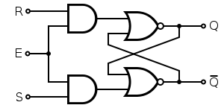

**Types of flip flops:**

**There are different types of flip flops and these are:**

1. Set-Reset (SR) flip-flop or Latch.
2. JK flip-flop.
3. D (Data or Delay) flip-flop.
4. T (Toggle) flip-flop.

**R-S Latch vs R-S Flip-Flop:**

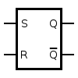The circuit is similar to R-S latch except enable signal is replaced by clock pulse.

An SR latch (Set/Reset) is an asynchronous device: it works independently of control signals and relies only on the state of the S and R inputs. In the image, we can see that an SR latch can be created with two NAND gates that have a cross-feedback loop. that latches can also be made from NOR gates, but the inputs are swapped and negated. In this case, it is sometimes called an SR latch.

**Circuit symbol for an SR latch**

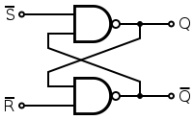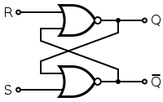

**SR latch made from two NOR gates.**

**RS latch made from two NAND gates.**

In some situations, it may be desirable to dictate when the latch can and cannot latch. The gated SR latch is a simple extension of the SR latch which provides an *Enable* line which must be driven high before data can be latched. Even though a control line is now required, the SR latch is not synchronous, because the inputs can change the output if the enable line is held high at length.

When the *Enable* input is low, then the outputs from the AND gates must also be low, thus the *Q* and *Q* outputs remain latched to the previous data. Only when the enable input is high can the state of the latch change, as shown in the truth table. When the enable line is asserted, a gated SR latch is identical in operation to an SR latch.

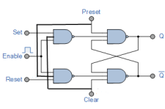

**D Flip-Flop:**

A D flip-flop has a single data input. This type of flip-flop is obtained from the R-S flip-flop by connecting the R input through an inverter, and the S input is connected directly to data input. The modified clocked R-S flip-flop is known as D flip-flop and is shown below. From the truth table of R-S flip-flop we see that the output of the R-S flip-flop is in unpredictable state when the inputs are high. In many practical applications, these input conditions are not required. These input conditions can be avoided by making them complement of each other.

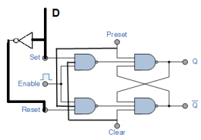

**Procedure:**

**1.** Connections are made as per circuit diagram.

**2.** Verify truth- tables for various combinations of input.

**Precaution:**

**1.** All the ICs should be checked before using the apparatus.

**2.** All LEDs should be checked.

**3.** All connections should be tight.

**4**. Always connect GROUND first and then VCC.

**5.** The circuit should be off before changing the connections.

**6.** After completing the experiment switch off the supply to apparatus.

**Lab Questions:**

**Q No. 1:**

Differentiate between combinational and sequential circuits.

Ans. **Combinational Circuit**:

* In this output depends only upon present input.
* There is no feedback between input and output.
* This is time independent.
* Elementary building blocks: Logic gates
* Used for arithmetic as well as Boolean operations.
* Combinational circuits don’t have capability to store any state.
* As combinational circuits don’t have clock, they don’t require triggering.
* These circuits do not have any memory element.

Examples:

Encoder, Decoder, Multiplexer, Demultiplexer

Block diagram:

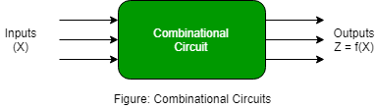

Sequential Circuit:

* In this output depends upon present as well as past input.
* Speed is slow.
* It is designed tough as compared to combinational circuits.
* There exists a feedback path between input and output.
* This is time dependent.
* Elementary building blocks: Flip-flops
* Mainly used for storing data.
* Sequential circuits have capability to store any state or to retain earlier state.
* As sequential circuits are clock dependent, they need triggering.
* These circuits have memory element.
* It is not easy to use and handle.

Examples:

Flip-flops, Counters

Block Diagram:



**Q No. 2:**

**What is a latch?**

**Ans.** Latch is an electronic device, which changes its output immediately based on the applied input. It is used to store either 1 or 0 at any specified time. It consists of two inputs namely “SET” and RESET and two outputs, which are complement to each other.

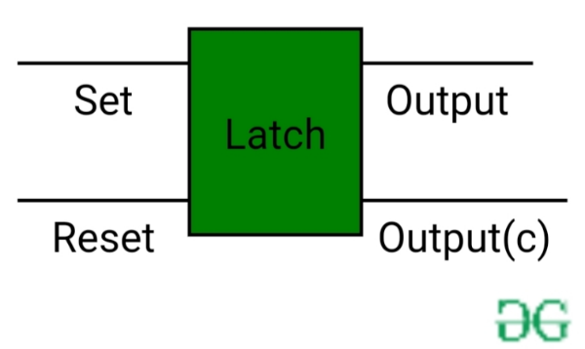

**Q No. 3:**

**What is a flip-flop?**

**Ans.** Flip-flop is a basic digital memory circuit, which stores one bit of information. Flip flops are the fundamental blocks of most sequential circuits. It is also known as a bistable multivibrator or a binary or one-bit memory. Flip-flops are used as memory elements in sequential circuit. The output is obtained in a sequential circuit from combinational circuit or flip-flop or both. The state of flip-flop changes at active state of clock pulses and remains unaffected when the clock pulse is not active.

